**DAILY ONLINE ACTIVITIES SUMMARY**

|  |  |  |  |  |  |  |  |  |
| --- | --- | --- | --- | --- | --- | --- | --- | --- |
| **Date:** | **14/06/2020** | | | | | **Name:** | **PRANEETA P HANDRAL** | |
| **Sem & Sec** | **4thSEM. & ‘B’ SEC.** | | | | | **USN:** | **4AL19CS401** | |
| **Online Test Summary** | | | | | | | | |
| **Subject** | | **null** | | | | | | |
| **Max. Marks** | | **30** | | **Score** | | | **Null** | |
| **Certification Course Summary** | | | | | | | | |
| **Course** | **Introduction to Information Security**  **Beginner**  **Skill level**  **Free**  **Course cost** | | | | | | | |
| **Certificate Provider** | | | **Greatlearning Academy** | | **Duration** | | | **5.5 Hrs.** |
| **Coding Challenges** | | | | | | | | |
| **Problem Statement:** Write a C program to remove specific characters in the String  **Example**  **If the original string is "Welcome to AIET" and the user inputs string to remove "co" then the it should print "Welme to AIET" as output .**  **Input**  **First line read a string**  **Second line read key character to be removed.**  **Output**  **String which doesn't contain key character** | | | | | | | | |
| **Status: Executed.** | | | | | | | | |
| **Uploaded the report in Github** | | | | | **Yes** | | | |
| **If yes Repository name** | | | | | **LockdownCoding**  <https://github.com/praneetahandral/lockdowncoding> | | | |
| **Uploaded the report in slack** | | | | | **Yes** | | | |

**Online Certification Course Summary:** Today I have learn about **What is the future of cryptography** and **Introduction to Software Security.**

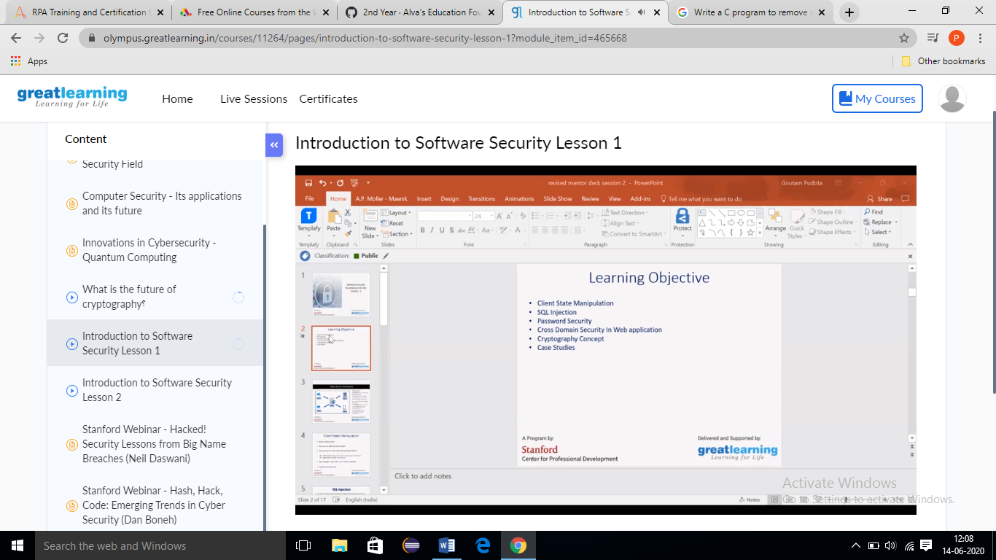

**Online Coding Summary: Today I received one program from Prof. Shilpa CSE Dept. The program is mentioned above. to my GitHub repository and I’ve shared the snapshot below.**

